Project Development Phase
Model Performance Test

Date | JUNE 2026
Team ID
Project Name | Visualization Tool for Electric Vehicle Charge and Range
Maximum Marks

Model Performance Testing:
Project team shall fill the following information in model performance testing template.
S.No. | Parameter | Screenshot / Values
1. | Data Rendered | 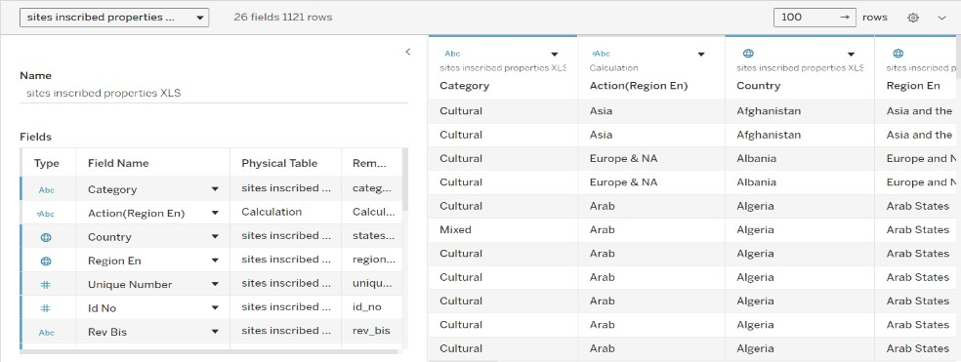  Successfully imported UNESCO dataset with fields including Name_en, Country, Region, Danger, Date_inscribed, and more. Data is correctly displayed in Tableau and linked to visualizations
2. | Data Preprocessing | Removed missing/null values, ensured data types (dates, strings, boolean) were correctly set, and added calculated fields such as year extraction from Date_inscribed. Filtered out redundant columns. Number of rows after cleaning data:1121
3. | Utilization of Filters | Implemented filters on Country, Region, Danger Status, and Year. Filters are interactive and applied to all visualizations for dynamic exploration.

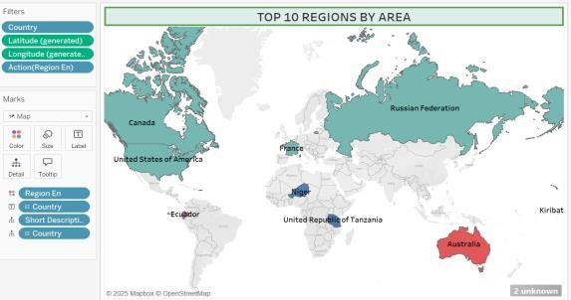
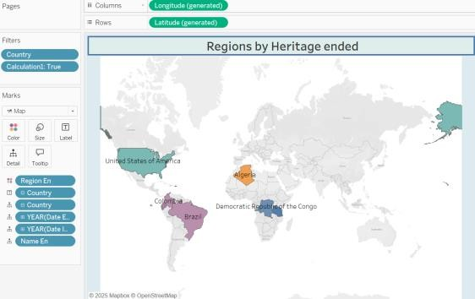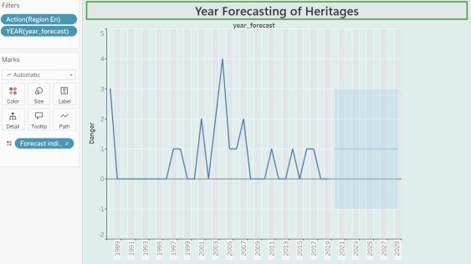
4. | Calculation fields Used | Year Extracted from Date_inscribed  - Count of Sites by Country  - Danger Flag Conversion for Pie Chart (IF [Danger] = 'Yes' THEN 'In Danger' ELSE 'Not in Danger')  - Region-wise Risk Rate: SUM(IF [Danger] = 'Yes' THEN 1 ELSE 0) / COUNT([Name_en])  - Decade of Inscription: INT(YEAR([Date_inscribed]) / 10) * 10  - Country-wise Site Percentage: (COUNTD([Name_en]) / TOTAL(COUNTD([Name_en]))) * 100
5. | Dashboard design | No of Visualizations / Graphs – 8  No of Dashboards designs- 2

 |  | 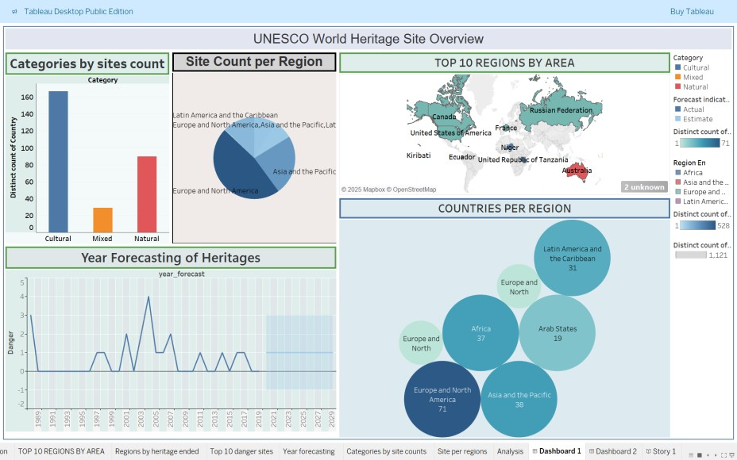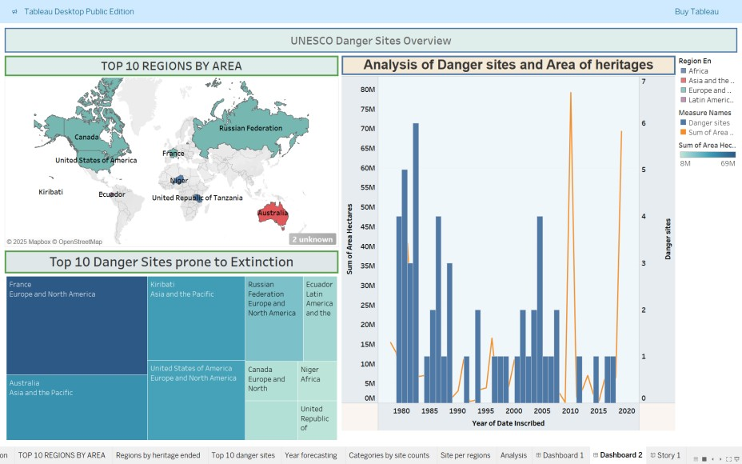
6 | Story Design | No of Visualizations / Graphs -8 No of Story Design- 1
